CHAPTER 6: The mysterious universe
Worksheet 6.4

The expanding universe
Student: Class:

The Doppler effect
1. Figure A shows a light emitting object moving to the right. The light emitted is detected by two stationary observers (O₁ and O₂). Figure B shows absorption spectra of a light emitting object. The dark lines represent light colours that have been absorbed by different elements in the star.
A |  | B
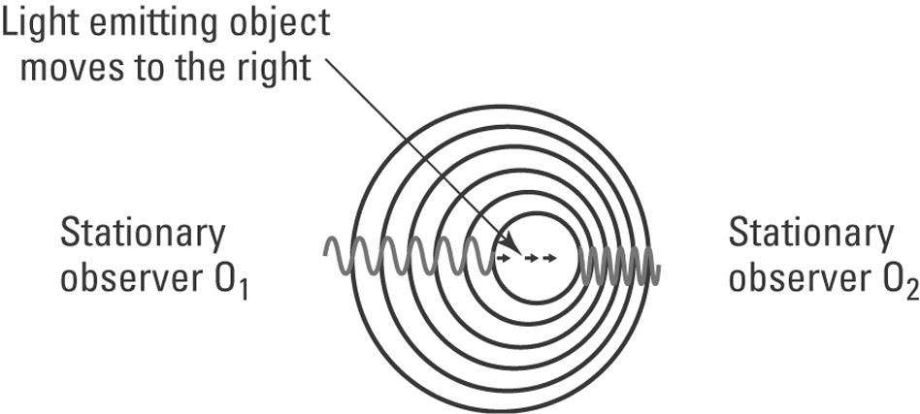 |  | 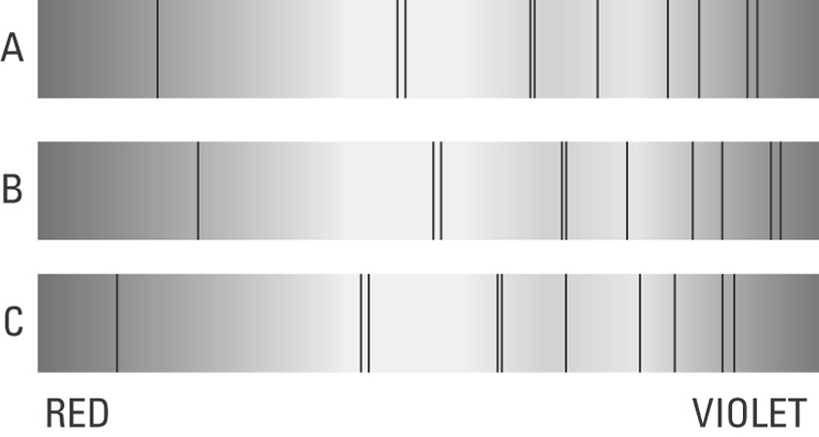
(a) Explain the Doppler effect using figure A.

(b) The dark lines in the spectra in figure B show red and blue spectral shifting. One spectrum is of a light source that is stationary relative to the observer. Identify the spectrum (X, Y or Z) in which the light emitting source is moving:
(i) away from the observer
(ii) towards the observer.
CHAPTER 6: The mysterious universe
Worksheet 6.4

Page 2

Hubble’s expanding universe
2. The following graph shows the velocities of a number of galaxies moving away from our galaxy versus their distance from the Earth.

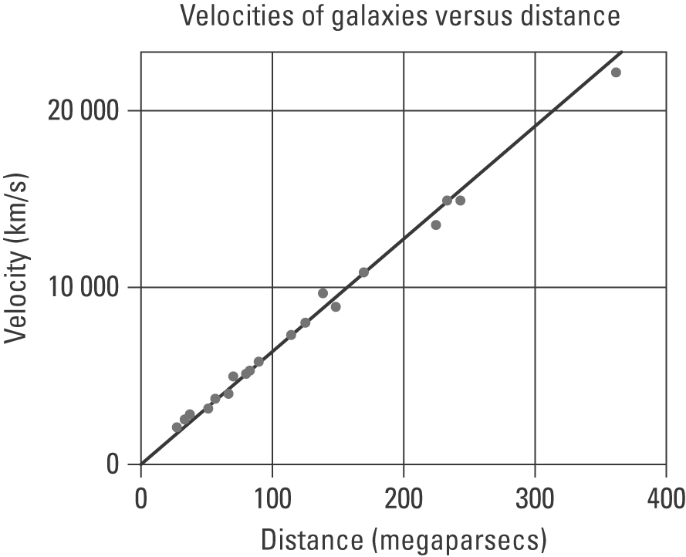
(a) Describe the trend demonstrated by the graph.

(b) Explain why these galaxies are moving away from our own.

